**Screenshot of Zap Test**

-No High Priority Security Issues

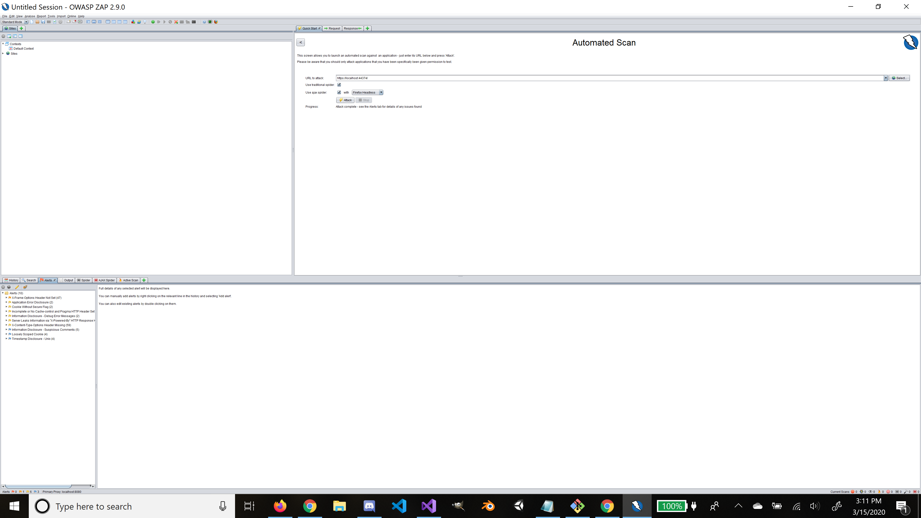

**Mitigation Code**

//Using for xtype header issues

app.Use(async (ctx, next) =>

{

ctx.Response.Headers.Add("X-Content-Type-Options", "nosniff");

ctx.Response.Headers.Add("X-Frame-Options", "SAMEORIGIN");

ctx.Response.Headers.Add("Cache-Control", "no-cache");

await next();

});

**After Screenshot**

